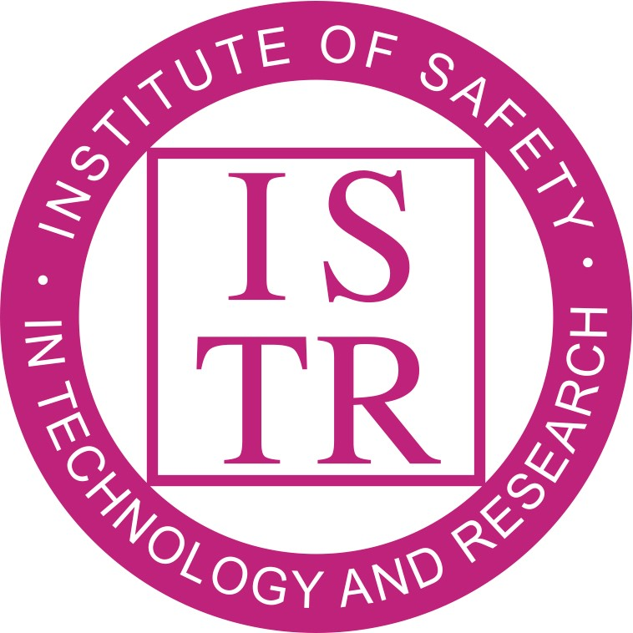
Institute of Safety in

Technology and Research

A meeting of the Executive Committee will take place on 05 September 2018 at 10:00 am in Room B02, Engineering and Science Learning Centre (ESLC), University Park, University of Nottingham, NG7 2RD.

AGENDA

- Apologies for absence
- Notice of AOB
- Approval of the minutes of the meeting held on 25 June 2018 at the University of Edinburgh
- Matters arising from the minutes of the last meeting
N.B. Minor changes such as spelling etc, should be communicated to the administrator. Only major changes will be dealt with at this meeting to save time.
- Treasurer’s report MC
- Membership Secretary’s report PB
- AGM and Symposia

- Update on Summer 2018 Symposium CD
- Autumn 2018 Symposia (21-22 Nov, Manchester, LEV) CD/JD
- Spring 2019 Workshop (12 March, Manchester, Engagement for Safety) CD/MH
- Summer 2019 Workshop (25 June, Nottingham, Human Factors) CD/AM
- Autumn 2019 Symposia EC
- ISTR website and Content Management System MH
- Training session on new website and CMS (membership, finance and voting) MH/CD
- BSG Update Jon Gawn (tbc)
- EC minutes/action table/summary EC
  - Key actions for members LM
  - Timescales LM
- AOB
- Discussion Equality
- Dates and venues of future meetings
05 September 2018, University of Nottingham
20 November 2018, University of Manchester
13 February 2019, Oxford (OUP)

